Language Arts: We will begin working with our new reading program this week—Benchmark. We will be working on the short /a/ sound. The words we’ll be working with are: back, cap, had, has, pack, pans, ran, sack, see, and she.
ACADEMICS
August 28 - 31, 2017

Room 10 News

We’ll continue with our personal narratives during our Room 10 Writers’ Workshop. Students will begin writing their stories.

Math: We will be problem solving using the 3-phase lesson, counting more collections, and working a bit in our math books.
ENRICHMENT
Art with Mr. Miceli begins on Tuesday.
PE with the coaches begins on Wednesday. Please wear appropriate shoes.
Computer Lab, Science Lab and Library will begin next week.
HOMEWORK

Monday: Word Shapes
Tuesday: No Homework
Wednesday: Grammar
Thursday: Math

If any of these homework sheets takes longer than 10-15 minutes, you may write me a note. Your child will receive full credit.
Reading Log: Read for at least 10 minutes each night. (Due the next Monday)
Announcements:
I hope to see you all at Back-to-School Night on Tuesday, August 29 at 6:00. We’ll be meeting in the auditorium with all the first-grade teachers to start. Then we’ll move to Room 10 for the final part.
Thank you to everyone who has brought in wish list items! We have some terrific new supplies for our class. Thank You! Thank You! Thank You!
No School on Friday September 1 (Admissions Day) and Monday, September 4 (Labor Day).

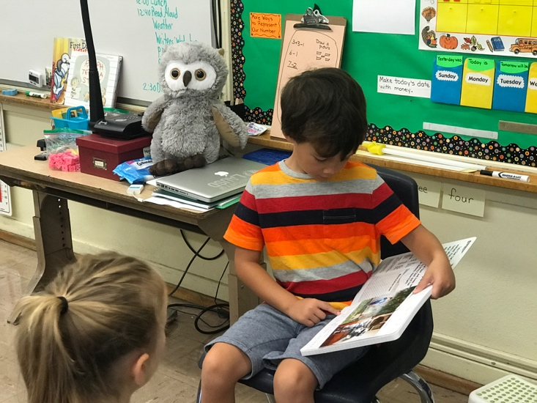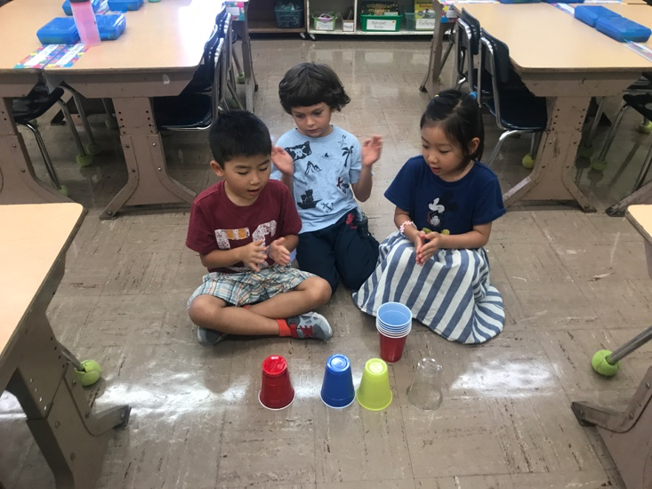

Opal Shares Music Rhythms with Cups

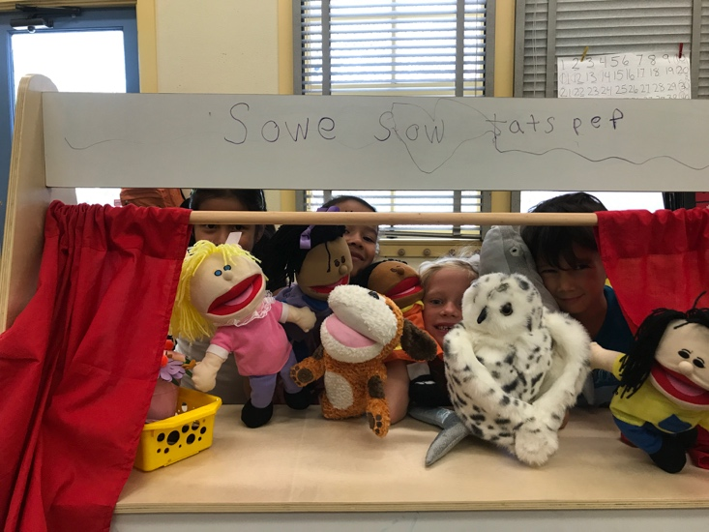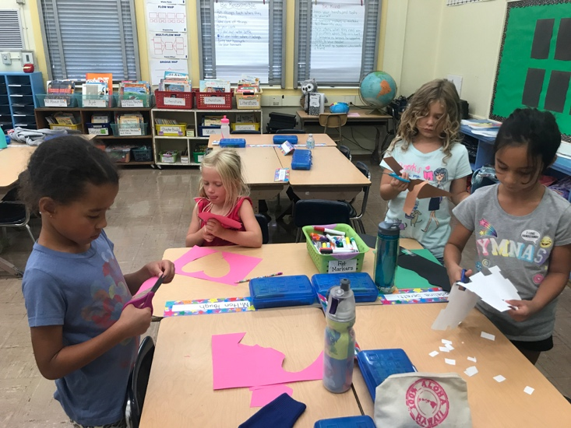

Learning Centers—Puppet Theater Learning Centers—Art

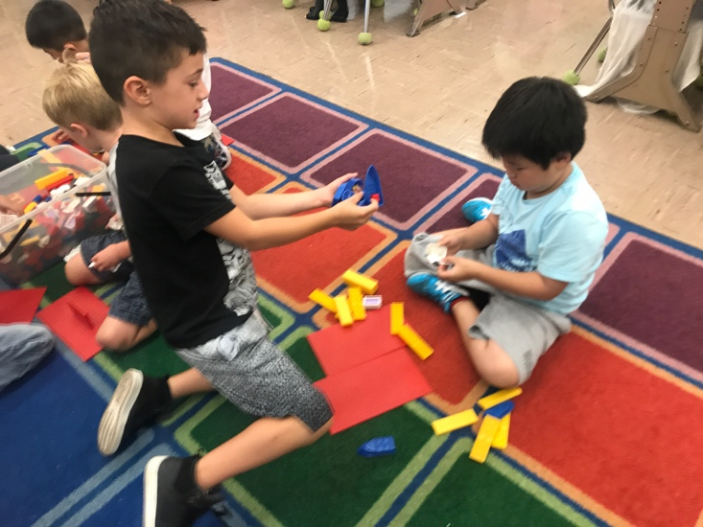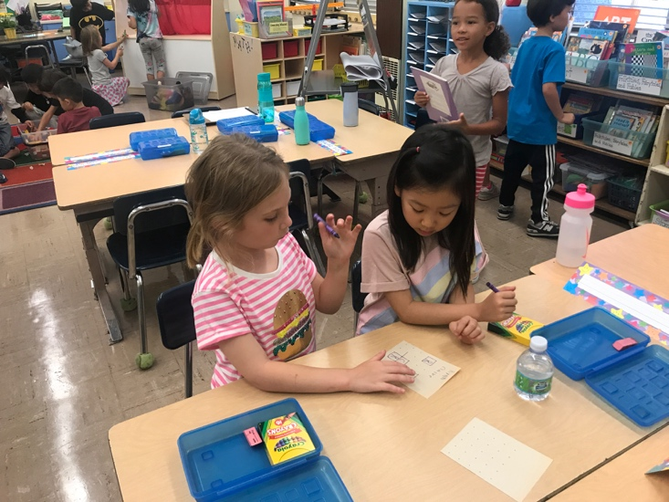
Learning Centers—Legos Learning Centers—Squares Game

Contact Info: I may be reached via email at had5368@lausd.net. Our temporary class website is at msdotsonroom10.weebly.com

